LAB REPORT实验报告
Lab Title | Final Lab |  |  |  | Lab No. | 16
Stud. Name | Jiang Yunxiang | Major | CST |  | Class
Student ID | 2022102330 |  | Date | 6/9
Lab description/objectives:
A palindrome string is a string that reads the same backward as forward. For example, "racecar" is a palindrome string because it reads the same way from left to right and from right to left. Another example is "level".
Write a C program to check whether a given string is a palindrome or not.

#include<stdio.h>
#define MAX 1005
#include<string.h>
#include<stdlib.h>
int main()
{
printf("plz enter a string and then we will check it out whether it is a palindrome string:\n");
char str[MAX] = "";
scanf("%s", str);
int j = strlen(str)-1;
int k = 0;
do
{
if (str[k] != str[j])
{
printf("The string is not a palindrome string!");
exit(0);
}
else if (k > j)
{
printf("The string is a palindrome string!!!");
exit(0);
}
else
{
k++;
j--;
}
} while (str[k] == str[j]);
return 0;
}
Program outputs:
（Paste the screenshot of program output here）
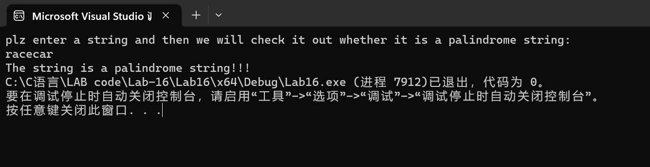
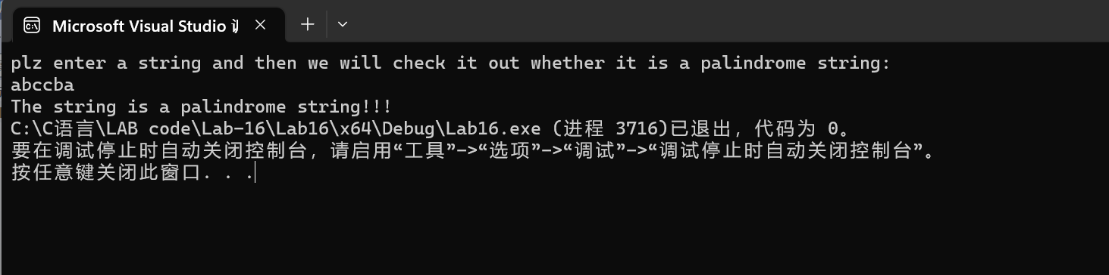

Discussion:
1．Most difficult parts
（What were the most difficult parts of your program to implement?）
Nope
2．Bugs and/or Errors
(List all the program bugs/errors you encountered and how you corrected them.)
Nope

